**Circuit Land: Unite the components, defeat the virus**

This game is based on electronic theme to bring the electronic components to life in a fun and engaging way in a game. This game belongs to the Tower Defender genre.

**Story of the Circuit Land:**

In a world unlike any other, hidden beyond the screens of our devices, lies Circuit Land—a thriving digital metropolis where every byte and bit flows seamlessly, and electronic components live in harmony. For years, the processors hummed with energy, keeping Circuit Land alive and safe. The resistors ensured stability, the capacitors held the charge, and the mighty IC Chips made decisions that powered entire systems.

But in the shadows of the mainframe, a sinister force was brewing. A digital virus, powerful and relentless, has escaped the confines of corrupted data and begun spreading through the circuits, seeking to take control. As the virus spreads, it corrupts everything in its path—turning once-loyal components against each other, breaking down the very core of Circuit Land

You are the Defender of Circuit Land. It is your duty to protect the central processor from the invading viruses that threaten to consume it. Use the power of electronic components—resistors, capacitors, inductors, and IC Chips—to fight back against the encroaching corruption. Strategize, build your defences, and stop the virus before it’s too late.

As you progress, you’ll unlock the mysteries behind this digital invasion—discovering who unleashed the virus and what it truly seeks to gain. Will you rise to the challenge and restore order to Circuit Land, or will the virus plunge it into chaos?

The survival of Circuit Land is in your hands. The viruses are advancing. Ready your defences. The time to fight back is now. Save Circuit Land before it’s too late!

**Game environment:** A Key distinguishing factor from Plants Vs Zombies

1. Electrobyte: based on electrons. These electrobytes have a value of 50 and can be collected by the player and traded for characters.



1. Electroblot: Rex shoots electroblots to fight and kill the Viruses.

 



1. Characters:

Cappy: The capacitor, stores charge. This character gives out electrobytes throughout the game.

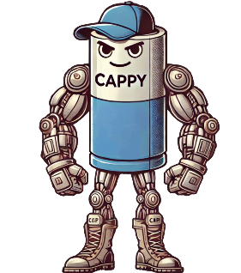

Rex: The resistor, shoots electroblots at the enemy virus.

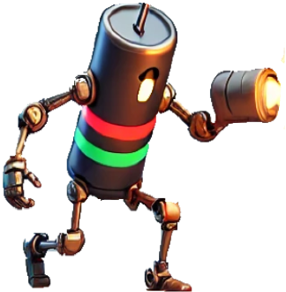

Indie : The Inductor, creates a magnetic field to slowdown Viruses.As the Viruses attack Indie, the magnetic field around her gets destroyed and finally the Indie itself.

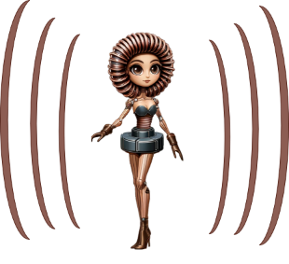

Virus: Malicious Virus that is attacking the Circuit Land. Colour of the virous changes to more brownish colour as it is attacked.

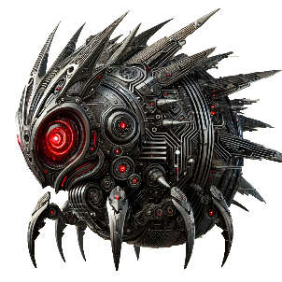

**Game Mechanics:** Initial version of this game is currently developed based on a popular tower defender game, Plants Vs Zombies. The idea is to get feedback from the play testers on the game world feel, testing out the characteristics of the characters based on electronic components while keeping the game play familiar and simple for the players.

* **Lane-Based Gameplay:**
* The game is divided into five horizontal lanes, and enemies (Viruses) walk along these lanes.
* Component characters are placed along these lanes to attack or hinder Viruses.
* **Resource Management (Electrobyte, characters):**
* Players collect electrobyte (a resource) to place characters.
* Electrobytes falls on to the board or is generated by Cappy (the capacitor), which the player can collect and trade for component characters to be place on the circuit board.
* **Tower Defence (Character Placement):**
* Players strategically place characters(defenders) on the circuit bord lane.
* Each character has a unique ability, such as shooting electroblots, blocking with magnetic field, or generating resources.
* Characters have different costs (in electrobytes) and recharge times before they can be placed again.
* **Virus Waves:**
* Viruses appear in waves and increase in number and strength as the game progresses.
* **Health System:**
* Each Virus has a set amount of health, and defender characters deal damage to them over time.
* Viruses must be destroyed before they reach the processor at the end of the lane.
* **Limited Resources:**
* Players need to balance their resources, as they have limited electrobytes and a limited number of character slots in their arsenal per level.

**How to Play the game:**

**Start:** Click on the Start button to start the game. This game can be played for about 5 minutes.

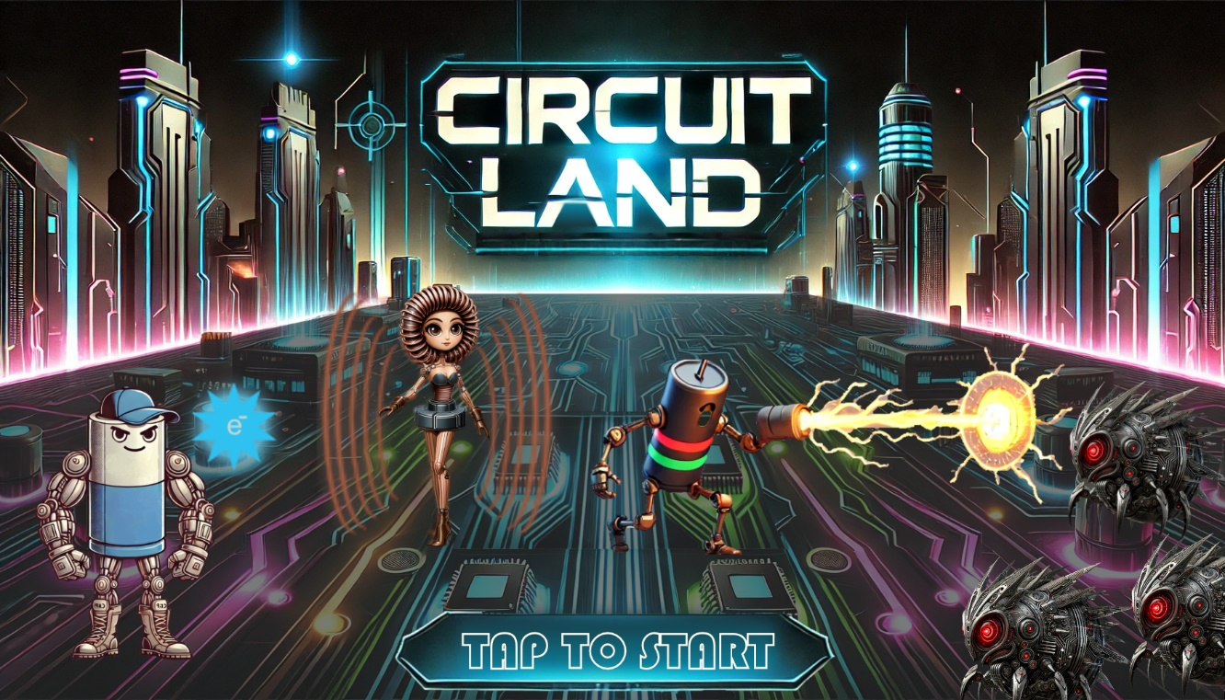

Game play screenshot:

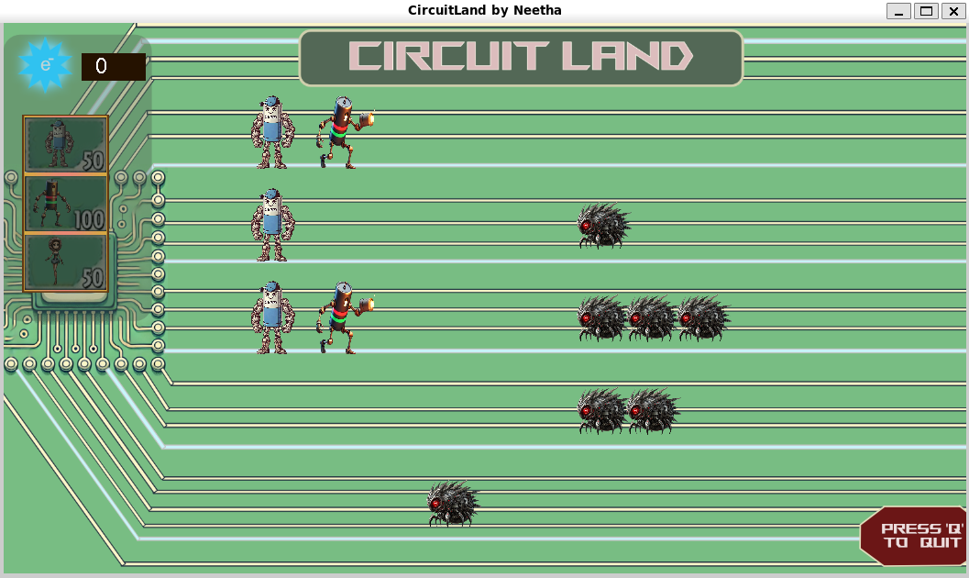

**A Video of the game:**



**Stop/Quit the game:** To quit the game, press ‘q’.

**Assets:** All assets used are created by me

**Implementation code:** code forked from <https://github.com/mhyousefi/ZombiesVsPlants>

**For Game Installation and execution, please refer to Circuit Land Installation.docx**



**Path to the Repo:** <https://github.com/NeethaUPrabhu/CircuitLand.git>

**Path to the executable:** <https://github.com/NeethaUPrabhu/CircuitLand/tree/46c45dc1c41025e397eb9b644946ef9a6575ab86/Executable>

**Known bugs:**

* When player taps on a character poster (to select it) and then immediately taps on the second/another poster to change the selection, it does not change the selection. It always places the character that the player has selected first and not the last.
* The game is unable to handle placing too many Indie character one shot (monkey testing)
  + I am not going to fix it as I would be creating another prototype incorporating the changes that I identified during play testing.